Press Information

Trade show: LogiMAT / Telematics
TIS introduces truck loading app

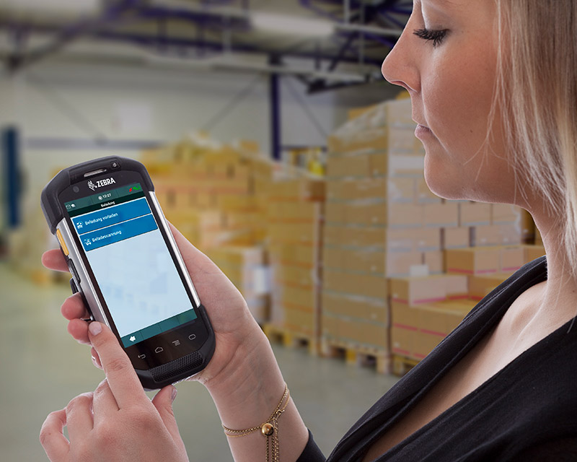

Android app for truck loading by drivers - Integrated scanning function - Interface to Transdata's transport management system Komalog - Alternative to terminal emulation - solution for drivers in urban transport without complex hardware
Source: TIS

Bocholt, March 13, 2018 - TIS GmbH, specialized in mobile telematics solutions for warehousing and transport, is presenting an Android app for truck loading at the LogiMAT trade fair (March 13 – 15, 2018) under the name "TISLOG mobile loading" for drivers in local traffic. The module has an interface to the Komalog transport management system by Transdata, which supported the project. Thus, the loading lists can be transferred directly from Komalog to the smartphone or scanner of the driver and be edited there, making a terminal emulation unnecessary. For barcode scanning, the module uses the camera or scanner integrated in the smartphone, thus ensuring seamless shipment tracking without hall scanners. With the "TISLOG mobile loading" module, TIS is aimed primarily at carriers who carry out the loading by the drivers and not by the warehouse staff. TIS is exhibiting in hall 8 at booth A05.
The application is based on the TISLOG logistics software and is suitable for all mobile devices with Android, which the driver carries with him for order management anyway. The solution is the latest addition to TIS's large family of modules for warehouse logistics, transport management on the go, fleet management and scheduling.
"TISLOG mobile loading" replaces terminal emulations and hall scanners and enables integrated processes with only one device and one software solution. "This allows the drivers to be guided through a predefined workflow, which makes the processes much more precise and reliable," explains TIS sales consultant Mike Ahlmann. As an example, he names the creation of photos of damaged loading means.
Another big advantage of the solution are the different data transmission paths. The communication between "TISLOG mobile loading" and Komalog takes place either via W-LAN or mobile radio, so that the loading progress and any changes can be reported back to the transport management system in real time even under adverse circumstances. The interface developed by TIS and Transdata works online.
At the LogiMAT, fair TIS will present the new truck loading app in a live scenario. Also on the booth will be TISLOG MDM, a newly developed TISLOG solution for mobile device management, as well as new in-house developed scan handles and charging stations. In addition, TIS will be showing the latest hardware developments from Honeywell and Zebra.

BACKGROUND The TIS GmbH

The TIS GmbH, headquartered in Bocholt is a market leader for advanced telematics projects
TIS stands for " Technische Informationssysteme " (Technical Information Systems) and is a rapidly expanding technology company with around 50 employees and its own hardware development department. The company has been developing intelligent products for mobile order management since 1985. Based on industrial PDAs and smartphones, TIS has implemented flexible telematics solutions for the logistics industry. Various technologies (GPRS / EDGE, WLAN, GPS, RFID, sensor technology) are combined to form complete individually customized systems. The main uses are groupage freight and cargo transport with integration of warehouse logistics. Special projects have resulted in special versions for gas and liquid transports, for waste disposal and for deposit logistics.

Company website: www.tis-gmbh.com

PRESS CONTACT
TIS Technische Informationssysteme GmbH | KfdM – Communication for mid-size businesses
Peter Giesekus  Müller-Armack-Straße 8  Technology Park Bocholt  D-46397 Bocholt  Phone: +49 28 71/27 22-0  E-Mail: marketing@tis-gmbh.de | Marcus Walter  Sudetenweg 12  D-85375 Neufahrn  Phone: +49 8165 / 999 38 43  Mobile: +49 170 / 77 36 70 5  E-Mail: walter@kfdm.eu

Status 02/2018

