Press Information

Trade show: transport logistic / Telematics
TIS: New devices and enhanced software

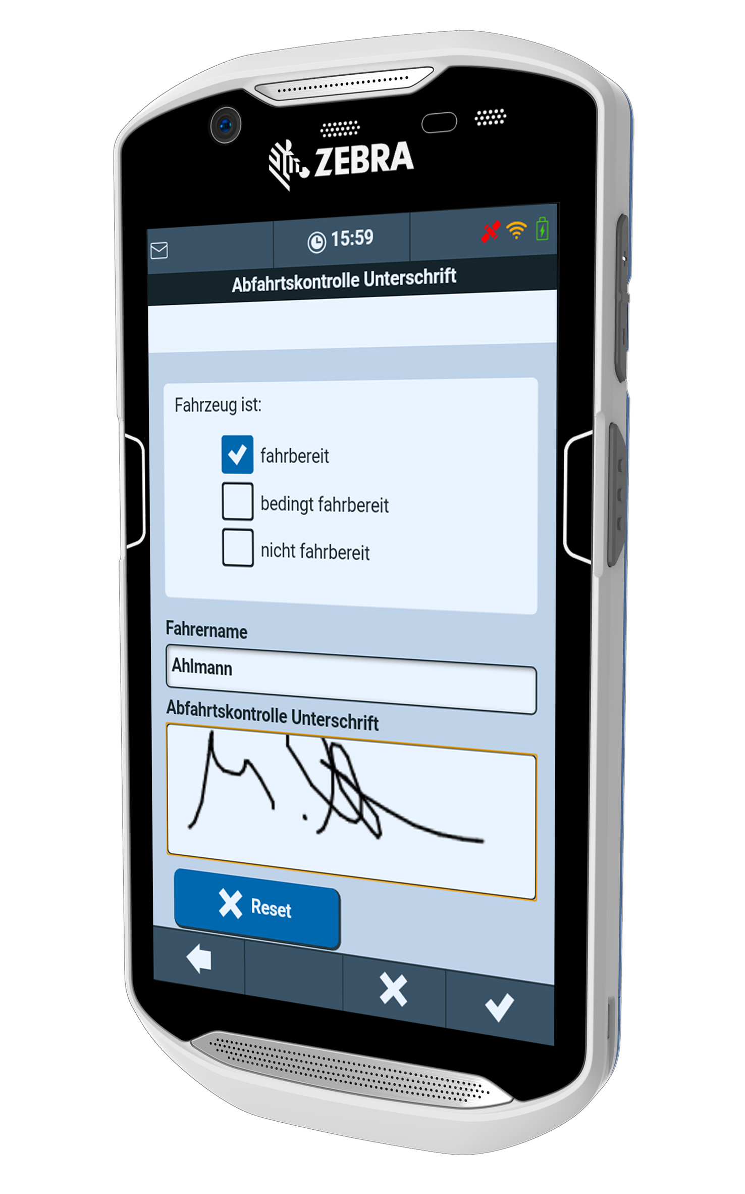

TIS is showing the Zebra TC56 at the transport logistic trade fair as a further hardware alternative. The help texts of the pictured app for the digital departure control are based on the specifications of the Berufsgenossenschaft BG Verkehr and have been approved for use with this app.
Source: TIS

Bocholt, April 2, 2017 - TIS GmbH, specialized in mobile telematics solutions for warehousing and transport, is presenting a new and tested terminal for the TISLOG mobile telematics solution with the Zebra TC56 at the transport logistic trade fair (May 9 - 12). Also new is the Alert Board, which actively draws attention to rule violations, deviations and other previously defined events. In addition, TIS will be showing the extended standby app, which enables the most important fleet, driver and tour data to be retrieved via smartphone. The new version even allows the rescheduling and scheduling of tours directly on the display. The standalone app for digital departure control, which was already introduced in February, has now been approved by the Berufsgenossenschaft BG Verkehr and will be available in the Google Playstore just in time for the transport logistic trade show. TIS will be exhibiting in Hall B2 at booth 317/518.
The Android-based Zebra TC56 in smartphone format convinces with an integrated scanner and a good price / performance ratio. The robust touch computer is suitable for use in the truck and is priced under its large brother TC75, which stands out among other things by its protective rubber reinforcements at the edges of the TC56.
The power-saving 64-bit hexa-core processor with 1.8 GHz combined with the Power Precision + batteries ensures good performance and uninterrupted operating times of up to 14 hours. The warm swap mode also allows the battery to be changed during operation and without restarting the device. The display with a screen diagonal of 5 inches is also easily readable in sunlight, the capacitive multi-touch panel can also be operated with gloves. The Corning Gorilla glass front also protects the TC56 from rapid wear.
The Alert Board is a new feature for the web-based information and disposition platform TISLOG office Infodesk. The "alarm block" shows at a glance all control deviations, unexpected changes of the plan and other events, which can be freely defined and categorized by the user. In addition, automated alerts can be set up via e-mail or SMS to several recipient groups in just a few mouse clicks. The application possibilities of the alert board are very versatile and range from the speed monitoring over conspicuous diesel consumption up to endangered delivery times.
The new flashlight function for mobile devices with integrated LED light, which can be activated with two clicks from any application via the so-called "action menu", is also very handy. The function has been specially developed for departure control in order to make it easier for drivers to view their vehicle even in the dark.
The app is an end-to-end solution for efficient and safe truck departure control using digital lists and an integrated photo function. The application is based on the TISLOG logistics software and is suitable for all mobile devices with Android, which the driver carries with him for order management anyway. The driver only needs four clicks and a signature for a fault-free departure control, which is about 95 percent of the reports. Just in time for the trade show, the departure control will be available for download as a standalone solution in the Google Playstore free of charge for the individual driver.
On the transport logistic, TIS also shows all other available modules from TISLOG mobile. Under the name "TISLOG intra Vis", the telematics experts provide, for example, an optical search aid for the warehouse. Developed in cooperation with DIVIS (Deutsche Industrie Video System GmbH), the solution supports drivers and warehouse staff by finding a fast-retrievable photo showing the colli in their current storage position.
With regard to hardware, customers can choose from the available mobile devices with Android operating systems. In addition to commercial standard smartphones, industrial touch-based computers such as the TC8000 or TC75 from Zebra and the ScanPal EDA50 from Honeywell are also available. All three units are part of the tested TISWARE product portfolio and can be inspected at the trade show booth.

BACKGROUND The TIS GmbH

The TIS GmbH, based in Bocholt is a market leader for advanced telematics projects. TIS stands for “Technische Informationssysteme” (Technical Information Systems). For over 25 years now, the company develops intelligent products for mobile order management.
Based on industrial PDAs TIS has realized flexible telematics solutions for the logistics industry under the brand PSV3. Several technologies (GPRS/ EDGE, Wi-Fi, GPS, RFID, sensor technology) are merged into complete and customized systems. Key applications include groupage freight and full truckload services with integration of warehouse logistics. In special projects special versions for gas and liquid transport as well as for disposal and deposit logistics have emerged.

Company website: www.tis-gmbh.com

PRESS CONTACT
TIS Technische Informationssysteme GmbH | KfdM – Communication for mid-size businesses
Peter Giesekus  Müller-Armack-Straße 8  Technology Park Bocholt  D-46397 Bocholt  Phone: +49 28 71/27 22-0  E-Mail: marketing@tis-gmbh.de | Marcus Walter  Sudetenweg 12  D-85375 Neufahrn  Phone: +49 8165 / 999 38 43  Mobile: +49 170 / 77 36 70 5  E-Mail: walter@kfdm.eu

Status 03/2017

