Press Information

Telematics / Transportation Management
TIS develops standby app
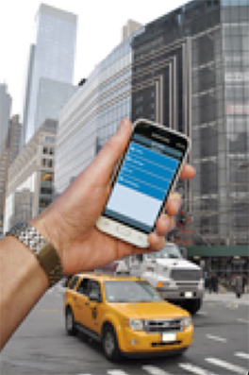
The standby app shows dispatchers and supervisors information on drivers and vehicles at each location. Source: TIS.
TISLOG mobile Office offers fast retrieval of the most important fleet data via smartphone - position data, driving times and driving communication - app is aimed at entrepreneurs and dispatchers in the standby service

Bocholt, February 7, 2017 - TIS GmbH, which is specialized in mobile telematics solutions for storage and transport, has now developed a telematics app for dispatchers and contractors under the name "TISLOG mobile Office", which provides the most important fleet, driver and tour data by smartphone. The solution is based on the TISLOG logistics software and runs on all mobile devices with Android. With the new app, TIS is primarily aimed at dispatchers in standby services and entrepreneurs who want to access data from anywhere in order to make informed decisions and communicate directly to the respective drivers. TIS is exhibiting on LogiMAT trade fair and is presenting in Hall 7 at Stand A05 / A07.
The standby app primarily provides information about drivers and vehicles. It shows the current balance of driving, resting and working hours as well as the last reported tacho status. An integrated search function makes it easy to find individual drivers that can be selected and called directly from a list. With the mail function individual, several or all drivers can be contacted with a written message at once. Distinct symbols indicate whether the message has been sent or read.
The vehicle number, license plate number and VIN are displayed for each truck. The last reported position data of selected vehicles or fleets are displayed on a map together with the license tag number or vehicle number. The app also provides access to all company and product news that TIS publishes on its own website in a weekly rhythm.
"In the next step, the standby app will also display the order data and stop lists," says Mike Ahlmann, who is responsible for the development of the app at TIS. In principle, the new app is "the mobile version of the web-based information and disposition platform Infodesk".
In May 2015, TIS had completely restructured its product range. Under the name of TISLOG Logistics & Mobility, the medium-sized family company offers a modular solution package for small, medium and large companies, which is constantly being further developed.

BACKGROUND The TIS GmbH

The TIS GmbH, based in Bocholt is a market leader for advanced telematics projects. TIS stands for “Technische Informationssysteme” (Technical Information Systems). For over 25 years now, the company develops intelligent products for mobile order management.
Based on industrial PDAs TIS has realized flexible telematics solutions for the logistics industry under the brand PSV3. Several technologies (GPRS/ EDGE, Wi-Fi, GPS, RFID, sensor technology) are merged into complete and customized systems. Key applications include groupage freight and full truckload services with integration of warehouse logistics. In special projects special versions for gas and liquid transport as well as for disposal and deposit logistics have emerged.

Company website: www.tis-gmbh.com

PRESS CONTACT
TIS Technische Informationssysteme GmbH | KfdM – Communication for mid-size businesses
Peter Giesekus  Müller-Armack-Straße 8  Technology Park Bocholt  D-46397 Bocholt  Phone: +49 28 71/27 22-0  E-Mail: marketing@tis-gmbh.de | Marcus Walter  Sudetenweg 12  D-85375 Neufahrn  Phone: +49 8165 / 999 38 43  Mobile: +49 170 / 77 36 70 5  E-Mail: walter@kfdm.eu

Status 02/2017

