Press Information

Order in Orange

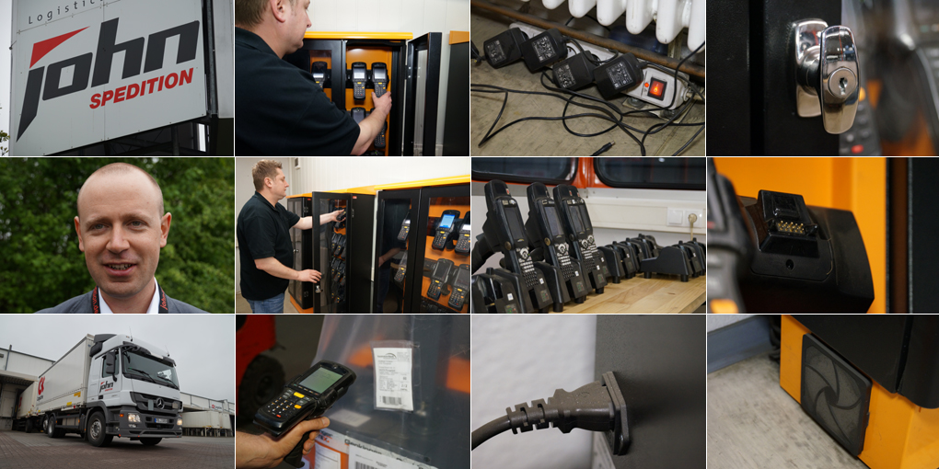

John Forwarding saves space and energy with a compact and secure storage solution for their warehouse scanners. Supplier of the cabinets is the TIS GmbH, who also provided the mobile data terminals.

Chaotic cable, dusty power strips, countless power supplies: This sight can be found in many warehouse offices where hall scanner required for the turnover of goods are stored and charged. Also at John Forwarding in Eichenzell that was once the case.
For barcode scanning of incoming and outgoing shipments, the company has over 50 mobile handheld terminals from Motorola in use. Most of them are only active at night - then the 70,000 square-foot transshipment hall serves as the central hub of the cargo cooperation CargoLine. During the day, the scanners are used for the remaining business of the logistics service provider. Two-thirds of the units have a break and recharge for the next shift - but there is no trace of the usual cable clutter at John Forwarding.
Higher energy efficiency
Instead in the warehouse office of the CargoLine founding member are three clean and lockable metal cabinets with a capacity of 20 scanners each. The devices are fixed accurately in five rows one above the other and connected to robust outlet strips with power supply. They are fed from a central transformer, which makes the many bulky chargers usually in use unnecessary. In addition, the cabinets have electrical ventilation that provides for a largely dust-free storage behind the Plexiglas doors.
"This solution creates order, is very compact and also saves us the acquisition of more than 50 individual power supplies," says Aleksej Dolheimer. After all, for professional hand-held scanners chargers are listed as single items on the price list and can now be waived cost-effectively. In addition, the energy efficiency of the three main transformers is significantly higher than the solution with individually switched-on power supplies. Another argument is the easier maintenance: The cabinets can quickly be cleaned with a wet wipe, while the individual chargers are very sensitive to moisture. "The cleaning of individual charging stations was therefore much more difficult in the past,” notes Dolheimer.

Modified hardware

The switch to the cabinet solution was initiated by the IT manager in 2013. At that time, a generation change in the mobile handheld terminals was due. John Forwarding opted for Motorola MC9590-type devices. Supplier was the TIS GmbH, to which John Forwarding was already standing in a long-term business relationship. Unlike their predecessors, the new devices can be used both for the business of freight forwarder and the hall turnover in the CargoLine Hub. The corresponding emulation software called Wavelink was also supplied by TIS. Wavelink can communicate with both, the employed software of active logistics in use at CargoLine and the transportation management system "ERPcargo" used by John Forwarding.
Other features of the hall scanners affect the hardware: The experts at TIS have complemented the robust exterior by essential hardware modules. The innovations include a base casing for active transponders for tracking and an ergonomic trigger handle. Both are not offered by Motorola. These additions transform the device into a multi-functional data terminal, which offers a scanner, camera, transponder and the ergonomics required by logistics.

First order of this kind

"For the new devices we wanted a lockable solution and wanted to move away from many cables and chargers," says Dolheimer. At first he thought of a customized solution manufactured by a carpentry business. But then the trained forwarder asked at TIS for advice. “Our contact had seen the cabinets recently at a trade show and was able to provide us with brochures,”
Dolheimer recalls. The orange special furniture was designed specifically for the MC9590 and comes from England. Two weeks later the order for three closets arrived at TIS - as the first order of its kind for the Bocholt telematics specialists. Just in time for delivery the warehouse office was then freshly painted and cleaned from the ground up.
In the next step John Forwarding will also make use of the other advantages of the new scanners. Because in addition to the universal emulation the devices configured by TIS master a particularly efficient form of photo documentation, which has been integrated into the normal workflow. The staff at John Forwarding can thus document certain special cases during the handling of cargo in the simplest manner, without putting the hand-held terminal or the scanner aside. The picture created is automatically linked to the previously scanned package number and thus clearly assigned.

More protection for added value

If something needed to be photographed, the staff of John Forwarding so far had to go and get a digital camera, create the photos and subsequently deliver them to the office. There the images were downloaded and provided with the package number in the file name manually. Against this background, the new solution was able to convince instantly during the test operation with two new devices: The simplified work flow through the integrated photo function abruptly led to a significantly increased amount of pictures and noticeably lowered efforts for post-editing. The result is a significantly better documentation of shipments. Soon, the new photo feature will go into actual operation at John forwarding.
Then the hall scanners will become even more valuable to the forwarder - one more reason for a safe and dustfree storage.

BACKGROUND John Spedition GmbH

The John Spedition based in Eichenzell is a medium-sized freight forwarding and logistics company, which operates both nationally and internationally. John Spedition is one of seven founding partners of the general cargo cooperation CargoLine Logistics Network GmbH, which was founded in 1993, and at the same time manager of the central hubs of CargoLine. In addition to the 10,000 square meter cargo handling area John Spedition has a 10,000 square meter logistics warehouse. The company's history goes back to 1945; Today the company has around 200 employees.

Company website: www.john-spedition.de

BACKGROUND The TIS GmbH

The TIS GmbH, based in Bocholt is a market leader for advanced telematics projects. TIS stands for “Technische Informationssysteme” (Technical Information Systems). For over 25 years now, the company develops intelligent products for mobile order management.
Based on industrial PDAs TIS has realized flexible telematics solutions for the logistics industry under the brand PSV3. Several technologies (GPRS/ EDGE, Wi-Fi, GPS, RFID, sensor technology) are merged into complete and customized systems. Key applications include groupage freight and full truckload services with integration of warehouse logistics. In special projects special versions for gas and liquid transport as well as for disposal and deposit logistics have emerged.

Company website: www.tis-gmbh.com

PRESS CONTACT
TIS Technische Informationssysteme GmbH | KfdM – Communication for mid-size businesses
Peter Giesekus  Müller-Armack-Straße 8  Technology Park Bocholt  D-46397 Bocholt  Phone: +49 28 71/27 22-0  E-Mail: marketing@tis-gmbh.de | Marcus Walter  Sudetenweg 12  D-85375 Neufahrn  Phone: +49 8165 / 999 38 43  Mobile: +49 170 / 77 36 70 5  E-Mail: walter@kfdm.eu

Status 07/2014

