Press Information

Telematics
Martin Baur GmbH switches to TIS

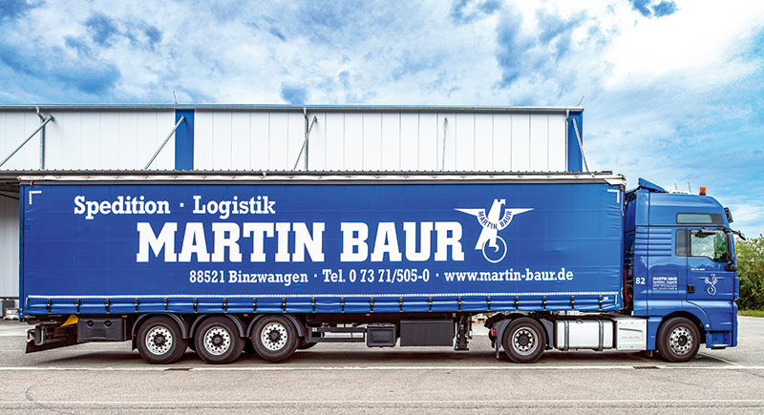

Bocholt, July 6, 2020 - Martin Baur GmbH, member of the CTL general cargo network, is planning to simplify its local and long-distance transport processes and warehouse handling with the TISLOG telematics solution from TIS. The switch will take place in two steps in the course of the introduction of the transport management system (TMS) Komalog from Transdata. Overall, Martin Baur GmbH expects a change in fleet costs and a significant simplification of administration.

As a first step, the 35 trucks for local and long-distance transport will be converted this year. Vehicle units of the TISPLUS telematicbox Truck 3 are installed, which are connected to the digital tachograph and the FMS/CAN interface. In addition to the pure location, the solution thus offers great potential for other functions, such as the remote transmission of driving and rest times. These are transferred from the tachographs to the telematics boxes and from there via mobile radio via the TIS data center to the TISLOG server at Baur. In addition, each vehicle receives a Samsung tablet with the TISLOG app, which drivers can use to call up their current driving and rest times, manage orders and update their shipment status.

By January 2021, the eight vehicles used in the CTL general cargo network are also planned to be converted to TISLOG. Here the drivers and the employees working in the warehouse are equipped with mobile TISLOG scanners. In the future, further expansion steps will follow, allowing, for example, the forklift movements in the warehouse to be controlled as well.

"In addition to the existing references, TIS is supported by the almost limitless expandability and versatility of the solution, which fulfills all of our requirements in local and long-distance transport as well as in the warehouse," explains partner Sina Baur. Adding to this does the "simple and far-reaching configurability with which TISLOG can be adapted to our own wishes".

Martin Baur GmbH is a third generation owner-managed family company that has over 200 employees and specializes in the business areas of transport, building materials, stones and earth. In the area of ​​forwarding, the versatile operation is involved in local and long-distance transport and organizes groupage, part-load and cargo transport. The partner of CTL-Cargo Trans Logistik AG has its own fleet of 43 trucks - including standard and special vehicles, as well as XXL vehicles for extra-wide vehicles of up to four meters.

The transport focus includes building materials as well as steel and machinery. The portfolio is supplemented by freight forwarding and storage halls with an area of ​​9,000 square meters. The company is based in Ertingen-Binzwangen in the western district of Biberach in Baden-Württemberg.
More information at www.martin-baur.de..

BACKGROUND The TIS GmbH

TIS GmbH, headquartered in Bocholt, is a premium provider of sophisticated mobile order processing and telematics. TIS stands for " Technische Informationssysteme " (Technical Information Systems) and is a rapidly expanding technology company with around 70 employees and its own hardware development department. The company has been developing intelligent products for mobile order management since 1985. Based on industrial PDAs, smartphones and tablets, TIS has implemented flexible telematics solutions for the logistics industry. The main uses are groupage freight and cargo transport with integration of warehouse and retail as well as various special mobile projects such as gas and liquid transport, disposal and deposit logistics. TIS serves more than 150 customers with more than 50,000 mobile units.

Company website: www.tis-gmbh.com

PRESS CONTACT
TIS Technische Informationssysteme GmbH | KfdM – Communication for mid-size businesses
Markus Vinke  Müller-Armack-Straße 8  Technology Park Bocholt  D-46397 Bocholt  Phone: +49 28 71/27 22-0  E-Mail: marketing@tis-gmbh.de | Marcus Walter  Sudetenweg 12  D-85375 Neufahrn  Phone: +49 8165 / 999 38 43  Mobile: +49 170 / 77 36 70 5  E-Mail: walter@kfdm.eu

Status 07/2020

