Press Information

CargoLine
Telematics: Kochtrans switches to TIS

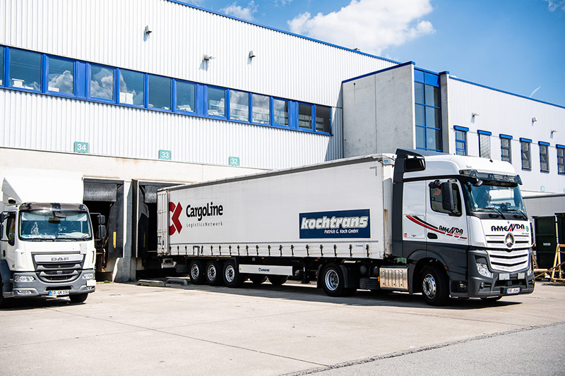

Kochtrans primarily aims to improve productivity with the TIS telematics solution.
Source: Kochtrans

Transport management and telematics solution TISLOG should deliver exact tour data and increase productivity - 100 trucks in local transport - implementation completed by July

Bocholt, May 5, 2020 Kochtrans Patrick G. Koch GmbH, part of the CargoLine groupage network, is investing in a new transport management and telematics solution from TIS and is primarily aiming to increase the productivity of their contractors. In the future, automatic notification based on the geofencing function is also planned. The introductory phase is scheduled to be completed by July 2020.

"With TISLOG, TIS offers us a future-proof transport management and telematics system that enables us to obtain exact key figures and statistical evaluations of the tours actually completed without wasting time," explains Kochtrans Managing Director Erich Baumgärtel. The company plans to use the figures above all for a performance-based and motivating remuneration for the 22 transport companies that work for Kochtrans around the Munich metropolitan area with 100 vehicles a day.

As part of the introduction, the drivers will be equipped with Honeywell EDA 51 mobile computers with a telematics app developed by TIS. The app can be easily configured with the new Live Configurator (www.live-konfigurator.com) and guides the drivers step by step through the delivery process between order receipt and delivery receipt.
At Kochtrans, TISLOG will not only play an important role on the mobile end devices, but also in the central disposition. Both pick-up and delivery scheduling are covered by TIS. Dispatchers will be able to track the location of the vehicles, the expected arrival time at the recipient and the pick-up status in real time.

Kochtrans Patrick G. Koch GmbH, based in Neufahrn near Freising, specializes in general cargo logistics. The company, founded in 1996, has been a subsidiary of the CargoLine general cargo network since 2009. Every day, 100 local transport vehicles transport an average of over 1,900 consignments (3,200 packages) in the incoming and outgoing goods. This makes Kochtrans one of the five largest general cargo forwarders in the Munich metropolitan area. Kochtrans has 7,500 square meters of storage space in Neufahrn, of which 4,500 square meters serve as a handling area. Further information at www.kochtrans-muenchen.de.

BACKGROUND The TIS GmbH

TIS GmbH, based in Bocholt, is a premium provider for sophisticated mobile order processing and telematics. TIS stands for "Technical Information Systems" and is a rapidly expanding technology company with over 70 employees and its own department for hardware development. The company has been developing intelligent products for mobile order management since 1985. Based on industrial PDAs, smartphones and tablets, TIS has implemented flexible telematics solutions for the logistics industry.
The main areas of application are groupage and cargo transports with integration of warehouse logistics and trade as well as various mobile special projects such as gas and liquid transport, disposal and deposit logistics. TIS serves more than 150 customers with more than 50,000 mobile units.
Company website: www.tis-gmbh.com

PRESS CONTACT
TIS Technische Informationssysteme GmbH | KfdM – Communication for mid-size businesses
Markus Vinke  Müller-Armack-Straße 8  Technology Park Bocholt  D-46397 Bocholt  Phone: +49 28 71/27 22-0  E-Mail: marketing@tis-gmbh.de | Marcus Walter  Sudetenweg 12  D-85375 Neufahrn  Phone: +49 8165 / 999 38 43  Mobile: +49 170 / 77 36 70 5  E-Mail: walter@kfdm.eu

Status 05/2020

