Press Information

transport logistic / Telematics / Digitization
TIS makes supply chains transparent

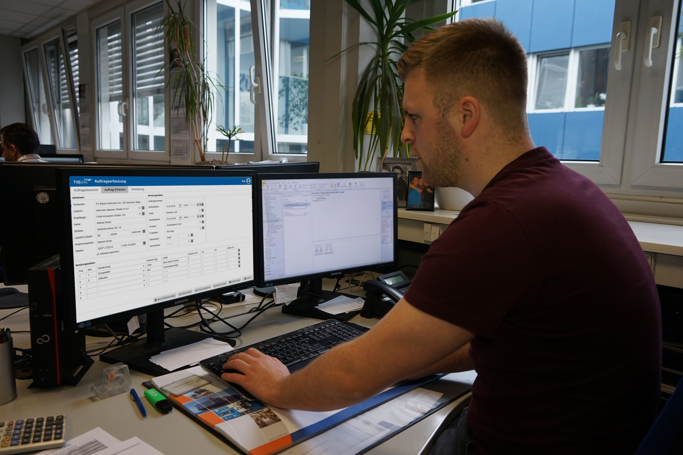

New module for online collection of pick-up orders - trade show offer for customers - legally secure archiving of tachograph data - exclusive insights into the inventory portal
Source: TIS.

Bocholt, May 15, 2019 - TIS GmbH, which specializes in telematics and fleet management, is presenting the software module TISLOG office Order Entry at the transport logistic trade fair (June 4 to 7), which now also allows for the collection of pick-up orders from the consignor. TIS offers this solution to all customers at the fair at a special price. In addition, TIS will be showing the archiving solution TISLOG office Tacho Archive, with which the data of the tachographs can be stored and analyzed legally safe. Also new is the internal inventory portal for the efficient and transparent processing of service and repair orders for hardware and software. As part of the fair, customers receive exclusive insights into the consistently digitized management solution. TIS will be exhibiting in Hall A3 at Stand 317/518. Also, again, the legendary TIS booth parties with live music will take place, which will be even bigger this year. Thanks to the support of the three main suppliers Honeywell, Zebra and Panasonic, the budget for drinks and meals has increased significantly and is open to all trade fair visitors.

The TISLOG office Order Entry module has been significantly expanded and now enables the return of status data in addition to the entry of pickup orders. With the solution, shippers can independently enter order information via a personal login, which then are available directly in the forwarder's disposition without media disruption. In addition, shippers can independently create users, enter loading points and recipient addresses, and much more. The solution eliminates the need for manual order entry for forwarding agencies, while their customers benefit from a high level of transparency: the current status of the consignments created by TISLOG office Order Entry can be tracked at any time and can also be combined with the ETA calculation in TISLOG office. Thus, the clients are informed about pickup delays. All pickup points can be geocoded automatically. TISLOG office order entry is available on-premise as a local installation or as a TIS-hosted cloud solution.

Legally secure archiving of tachograph data

The new standard TISLOG office Tacho Archive supports fleet operators in the legally required storage of the speedometer mass memory as well as the driver card. In addition, the solution can be used to take care of holiday, illness and absence days. In the case of violations of the driving time regulation, the system automatically generates the necessary driver information, which drastically reduces the administrative burden on fleet managers. The import of DDD files from driver cards and mass storage of the tachographs can be done fully automated via remote download or manually. An appointment overview in traffic light colors warns in time when the next legal archiving deadline for driver or vehicle data approaches. In addition, there is a detailed overview in which all DDD downloads are clearly displayed - with reference to the original DDD file. The export of DDD files for any checks by authorities is also conveniently done via the interface. In the set period of time, the data is compiled in such a way that the lowest number of violations is determined.

BACKGROUND The TIS GmbH

TIS GmbH, headquartered in Bocholt, is a premium provider of sophisticated mobile order processing and telematics. TIS stands for " Technische Informationssysteme " (Technical Information Systems) and is a rapidly expanding technology company with around 70 employees and its own hardware development department. The company has been developing intelligent products for mobile order management since 1985. Based on industrial PDAs, smartphones and tablets, TIS has implemented flexible telematics solutions for the logistics industry. The main uses are groupage freight and cargo transport with integration of warehouse and retail as well as various special mobile projects such as gas and liquid transport, disposal and deposit logistics. TIS serves more than 150 customers with more than 50,000 mobile units.

Company website: www.tis-gmbh.com

PRESS CONTACT
TIS Technische Informationssysteme GmbH | KfdM – Communication for mid-size businesses
Peter Giesekus  Müller-Armack-Straße 8  Technology Park Bocholt  D-46397 Bocholt  Phone: +49 28 71/27 22-0  E-Mail: marketing@tis-gmbh.de | Marcus Walter  Sudetenweg 12  D-85375 Neufahrn  Phone: +49 8165 / 999 38 43  Mobile: +49 170 / 77 36 70 5  E-Mail: walter@kfdm.eu

Status 05/2019

