Press Information

People / Telematics
TIS: Peter Giesekus is retiring

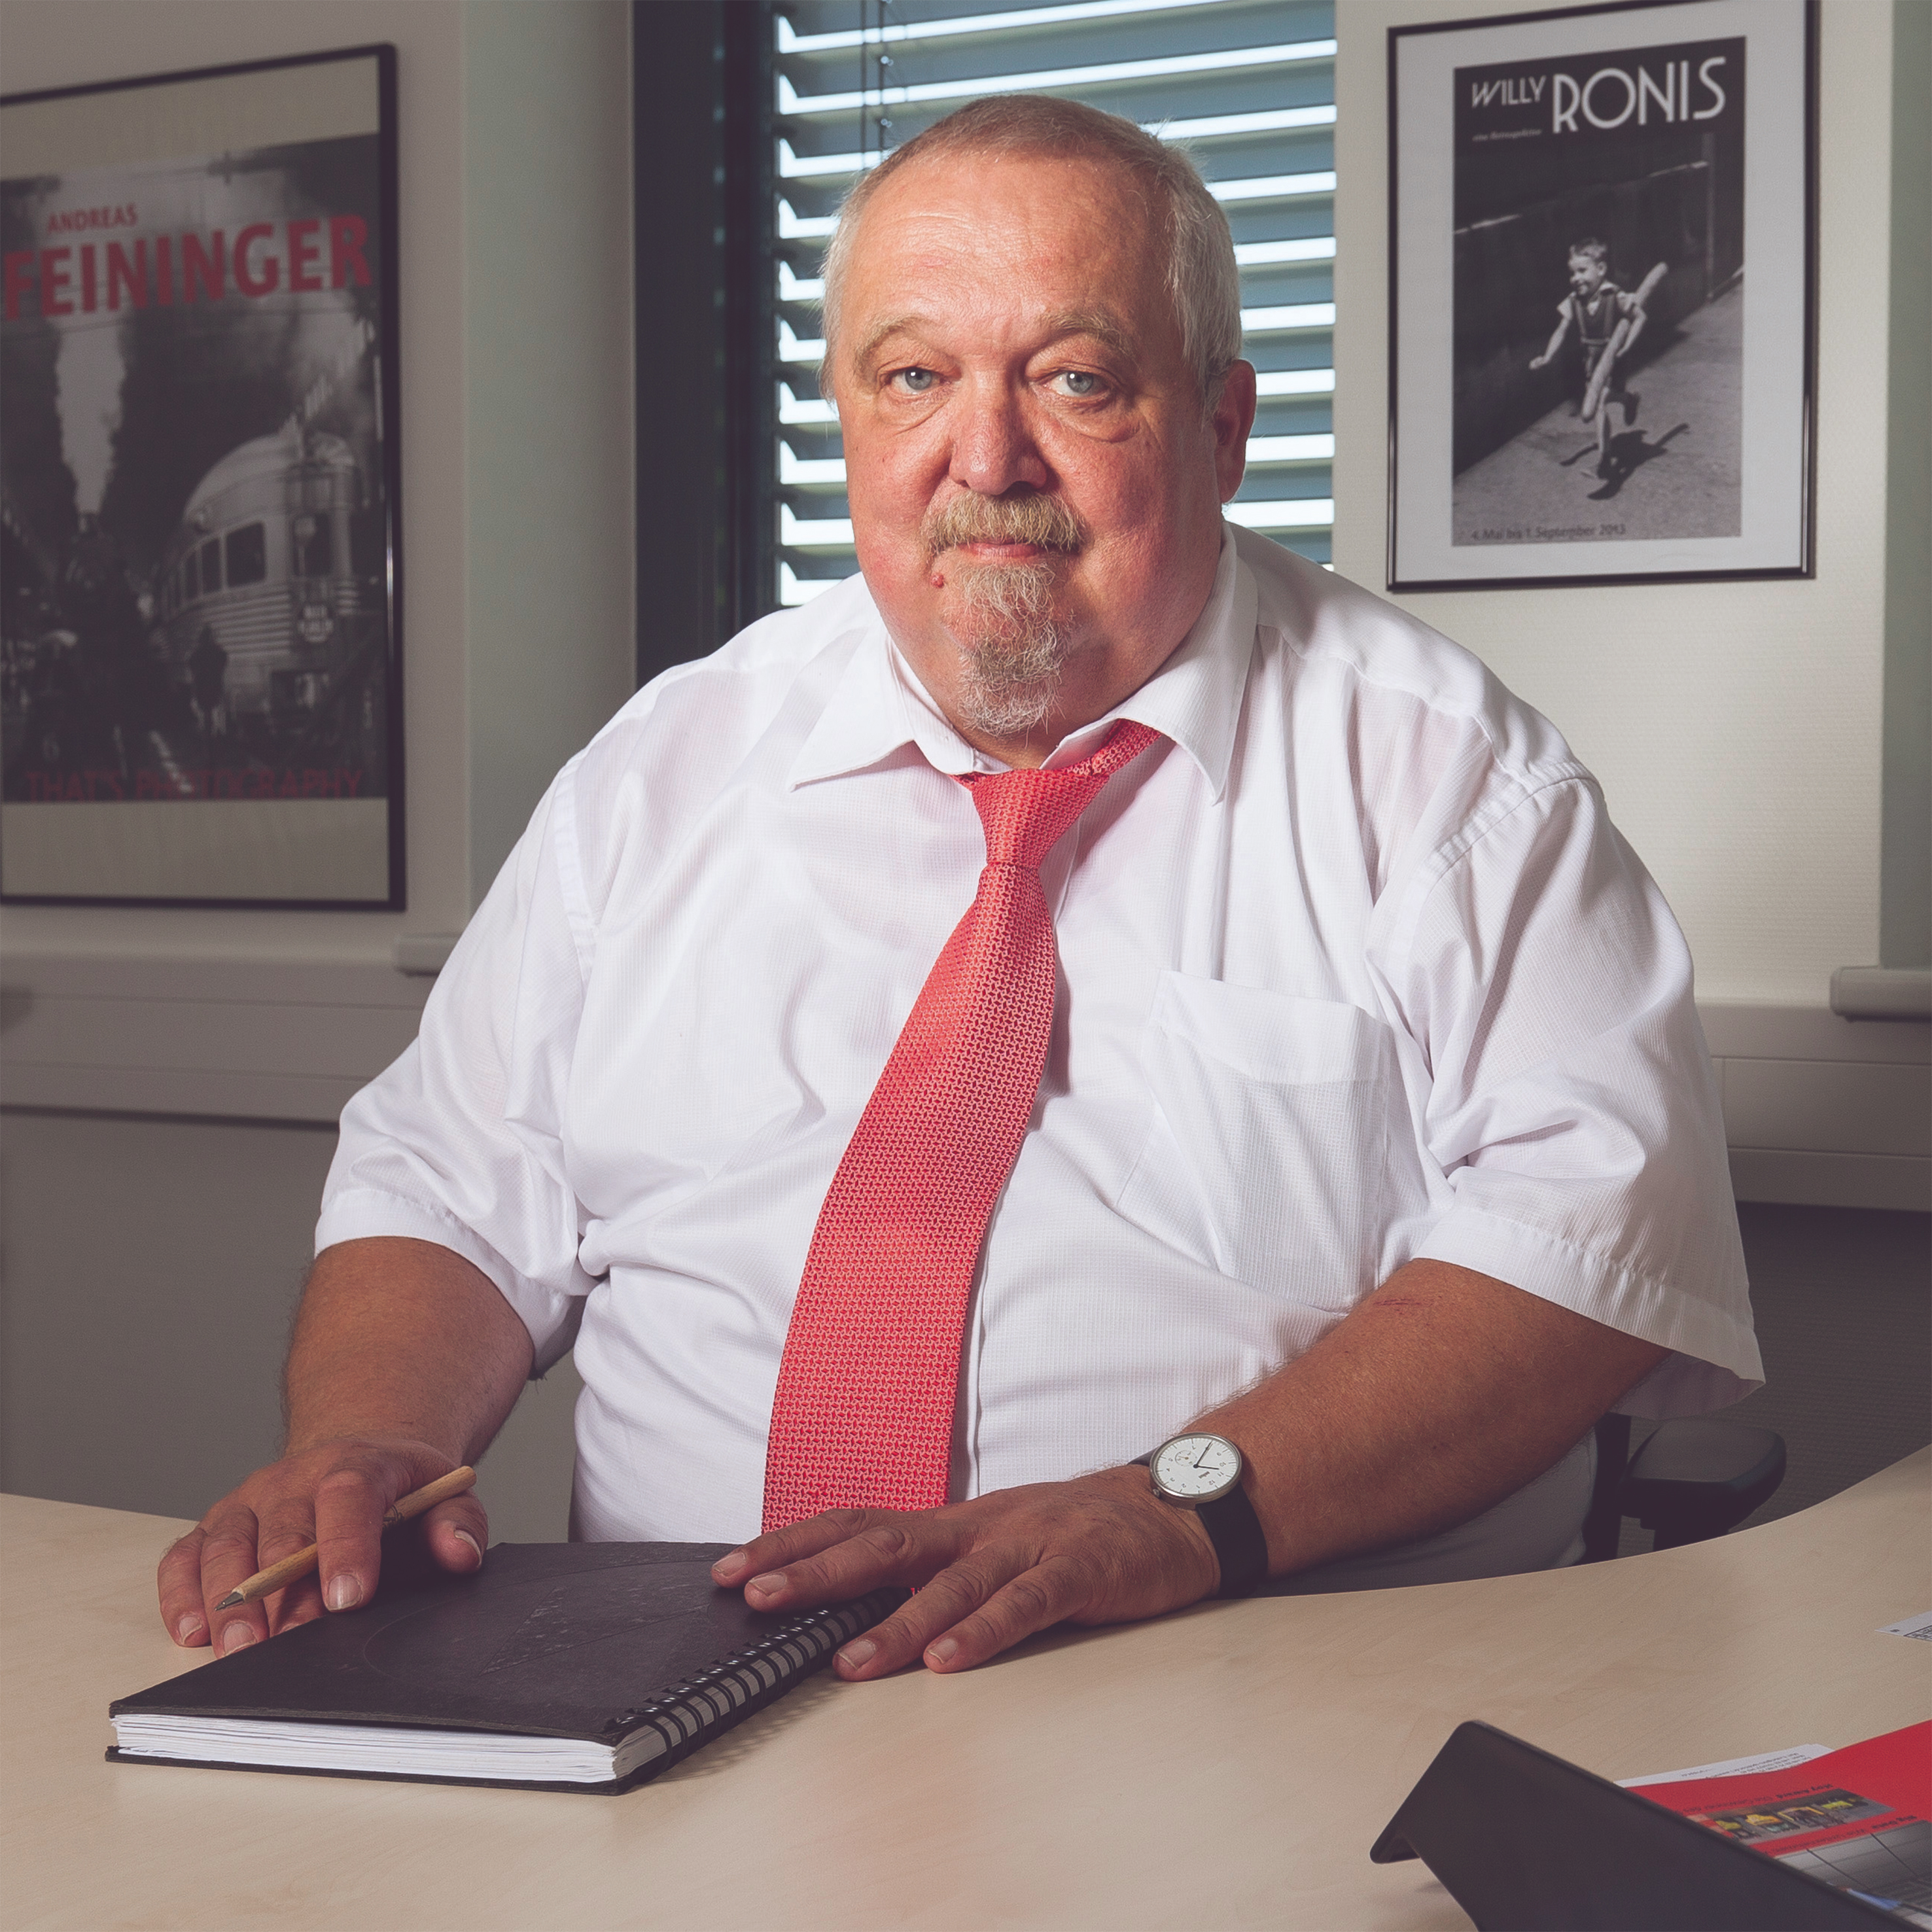

Peter Giesekus (63), Sales Director at TIS, is retiring on November 30th.
Source: TIS.

Bocholt, Mai 21, 2019 - Peter Giesekus (63), Sales Director of telematics provider TIS, is retiring on 30 November 2019. The trained forwarding merchant has been working for the Bocholt-based family business since 2008 and is considered one of the pioneers of mobile communication between trucks and disposition. Business friends and companions can meet the enthusiastic hobby musician from 4 to 7 June at the TIS GmbH stand during the transport logistic in Munich. TIS will be exhibiting in Hall A3, Stand 317/518.

After training as a forwarding agent in 1977, Giesekus made his first career steps with Danzas. In the following years, the practitioner took over management responsibility at various forwarding agencies and in 1986 he was already managing director of a medium-sized food forwarding agency with 150 vehicles.

After that, Giesekus turned to logistics IT and worked for software companies like Cap debis and PAS. Several larger projects sparked his interest in the possibilities of telematics in 1994. In 2000, he took over the management of Qualcomm QES GmbH, where he was responsible for the implementation of international telematics projects in Germany, Poland, Austria and Switzerland.
In 2008, Giesekus joined TIS GmbH as co-managing director and since then has been responsible for the sales department. "At TIS, I was able to really develop and experience a good working environment," explains the telematics veteran. "We have grown steadily for years and today make highly demanded projects in mobile order processing and telematics. With a clear focus on logistics and mobility, we are very well positioned in the market." Against this background, he will be able to say "goodbye" with peace of mind, and then have time for family, travel and music. "

His duties at TIS GmbH will be taken over by his managing colleague Markus Vinke, who will be assisted by head of sales Mike Ahlmann and the head of the project planning and support department Bernd Schmitz. The sales team has been sustainably strengthened since October 2018 by Oliver Krahmer, Daniel Schlütter and Fabian Bielefeld. A smooth transition and comprehensive customer care is thus guaranteed.

BACKGROUND The TIS GmbH

TIS GmbH, headquartered in Bocholt, is a premium provider of sophisticated mobile order processing and telematics. TIS stands for " Technische Informationssysteme " (Technical Information Systems) and is a rapidly expanding technology company with around 70 employees and its own hardware development department. The company has been developing intelligent products for mobile order management since 1985. Based on industrial PDAs, smartphones and tablets, TIS has implemented flexible telematics solutions for the logistics industry. The main uses are groupage freight and cargo transport with integration of warehouse and retail as well as various special mobile projects such as gas and liquid transport, disposal and deposit logistics. TIS serves more than 150 customers with more than 50,000 mobile units.

Company website: www.tis-gmbh.com

PRESS CONTACT
TIS Technische Informationssysteme GmbH | KfdM – Communication for mid-size businesses
Peter Giesekus  Müller-Armack-Straße 8  Technology Park Bocholt  D-46397 Bocholt  Phone: +49 28 71/27 22-0  E-Mail: marketing@tis-gmbh.de | Marcus Walter  Sudetenweg 12  D-85375 Neufahrn  Phone: +49 8165 / 999 38 43  Mobile: +49 170 / 77 36 70 5  E-Mail: walter@kfdm.eu

Status 05/2019

