TIS GmbH expands its existing building
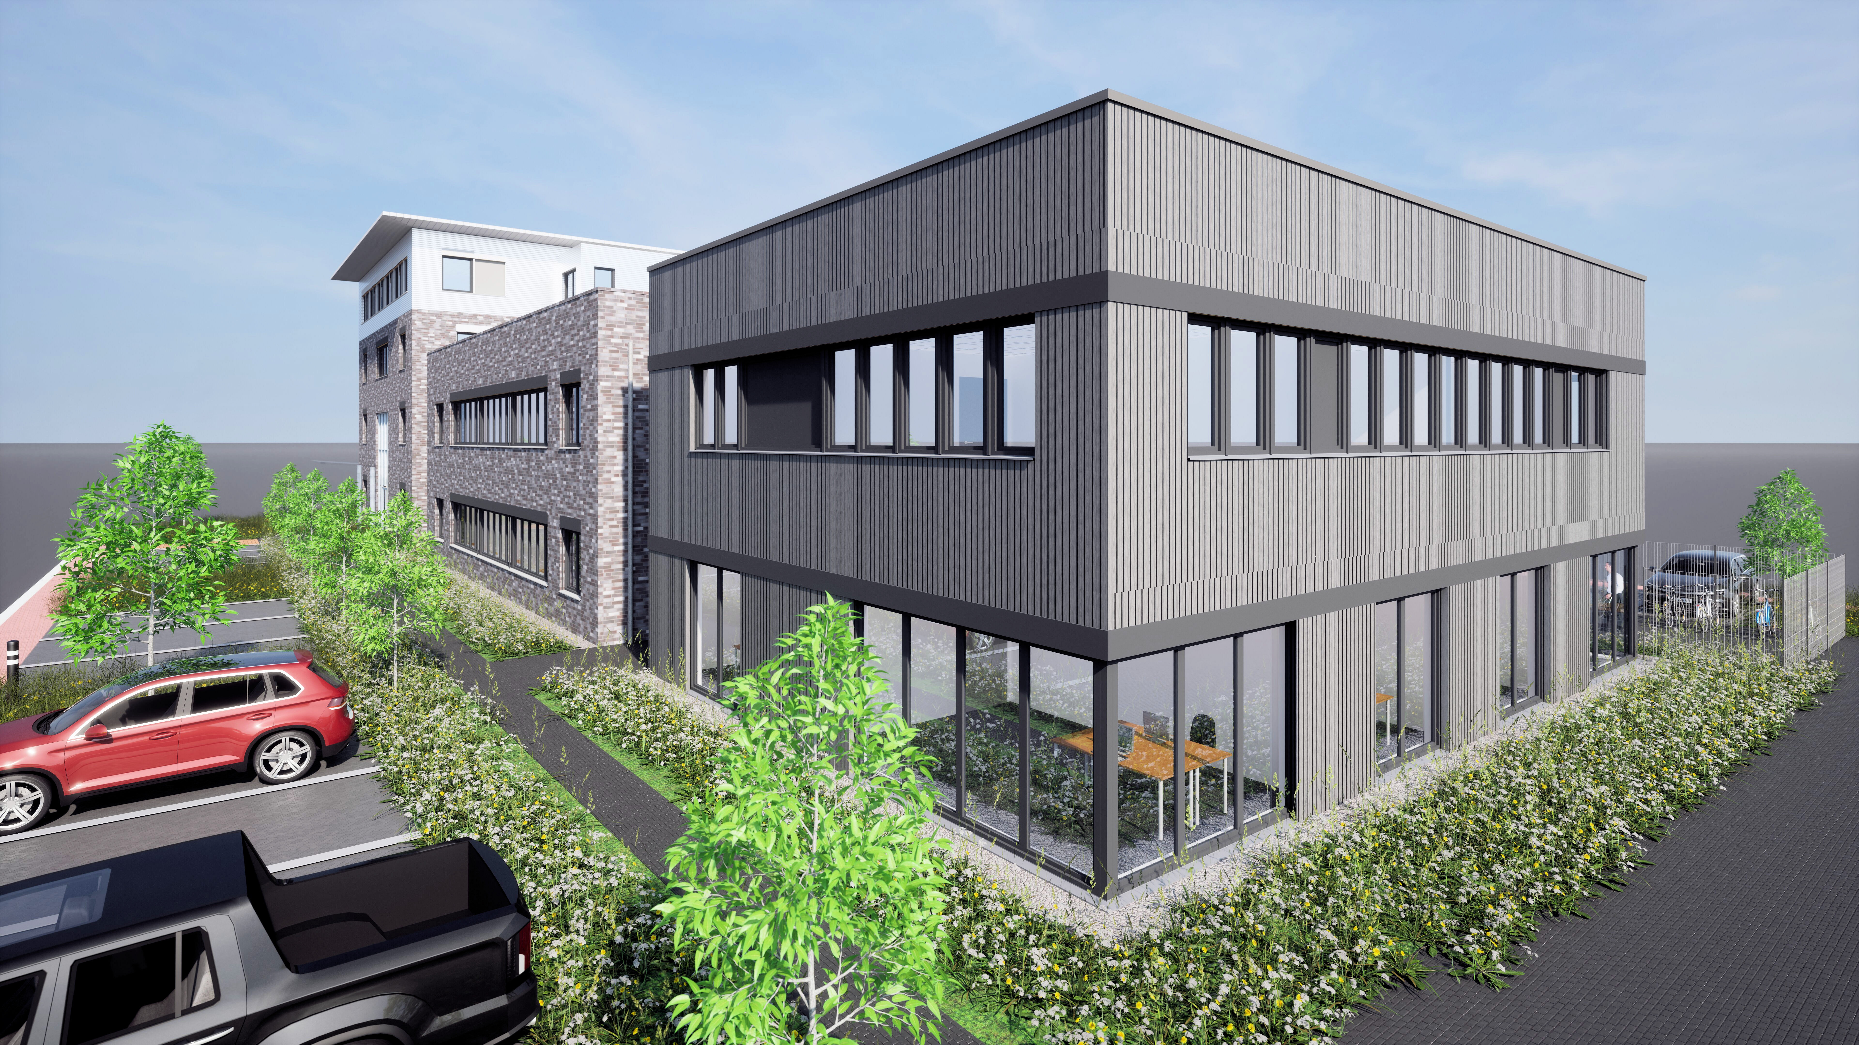

After TIS Technische Informationssysteme GmbH moved to the Bocholt Technology Park in 2013, the company building became too small after only a few years, so an extension was added in 2019, creating additional workplaces for employees. Now, in 2025, the existing building is being extended again to create enough office space for the growing number of employees.

TIS Technische Informationssysteme GmbH was founded in 1985 and started out as a basement and garage company. Over time, more and more employees joined the company, so that the location became too small and a company building was constructed in the newly created Bocholt Technology Park in 2019. Since then, the family-owned company has continued to grow strongly but at a healthy pace and is therefore already building its second extension, which will create space for 40 additional employees. TIS GmbH will then have a total of 140 workplaces at its disposal.

The first work on the new building began in March 2025. As it is a timber frame construction, the building was erected in just a few days, so that interior work could begin quickly. The first employees are expected to move in in November 2025. “We are well on schedule, so completion of the building in November remains realistic,” says company founder and owner Josef Bielefeld. Managing Director Fabian Bielefeld has focused on sustainability in the extension: “Wood frame construction is considered particularly sustainable. In addition, we will install PV systems on the roof, as we have already done on the existing building. Greenery is now also planned underneath these.”

TIS Technische Informationssysteme GmbH continues to feel very much at home in the Bocholt Technology Park, in close proximity to Westfälische Hochschule. As the company works closely with the university, the location was perfect from the outset. The company's dual students also benefit from the proximity, as they can quickly pop over. “The cooperation with Westfälische Hochschule is very important to us. We also regularly have students who write their bachelor's or master's theses with us,” says Markus Vinke, also managing director of TIS GmbH.

