TIS GmbH donates 3.000€ to NABU Foundation National Natural Heritage

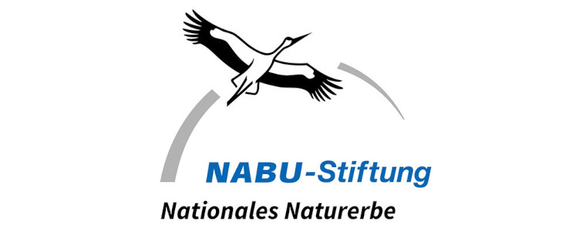

TIS GmbH from Bocholt has donated 3.000€ to the NABU Foundation National Natural Heritage. Therefore, the company supports the purchase of land at the Moselle to increase the habitat for animals such as the common tern.

The management of the company dangled the donation in front of the employees in order to achieve a certain amount of driven kilometers during this year’s stadtradeln (campaign to ride bike instead of using the car). As not only the managing directors advocate the nature protection but the employees as well, many of them took part in the activity to achieve the set kilometers. In the end, they achieved the goal and the donation was initiated.

The donation supports the purchase of land at the Moselle at Nenning at the border triangle of France, Luxembourg and Germany. Little by little the initiative buys shuttered gravel pits to offer rest areas to migrant birds such as purple herons, little egrets and night herons. In addition, rare and endangered birds (e.g. orpheus mocker, kingfisher and common tern) breed at the watercourse and its banks. Moreover, the yellow-bellied tad and different dragonflies settled there too.
The buying of the land enlarges the habitat of the mentioned animal species.

