**TIS GmbH donates 3.000 € to Kalangala e.V.**

**This year, TIS GmbH from Bocholt once again donated to Kalangala e.V., which supports orphans in Uganda.**

TIS GmbH regularly supports Kalangala e.V. with donations. Money was collected again at the last Christmas party. A total of €3,000 was raised. Half of the money comes from the employees and the other half from the Bielefeld family, who are the owners of TIS GmbH.

What was special this year was that Simone Zingel, first chairwoman of the social association, gave a short presentation at the family company's Christmas party. In this she showed which projects were recently implemented - also thanks to donations from TIS GmbH - and she once again demonstrated the benefits these projects bring to the lives of the orphans. Simone Zingel also brought illustrative material with her to show the children's way of life more clearly. All employees were excited to see what was happening with the donations and how it was making the lives of orphans in Uganda easier.

Fabian Bielefeld, managing partner of TIS GmbH, is pleased that a large amount of donations has once again been raised: “We are happy that all employees are contributing to the donations and that we can continue to support Kalangala e.V. this year.” According to Simone Zingel, the donation will be used for further training of the employees.

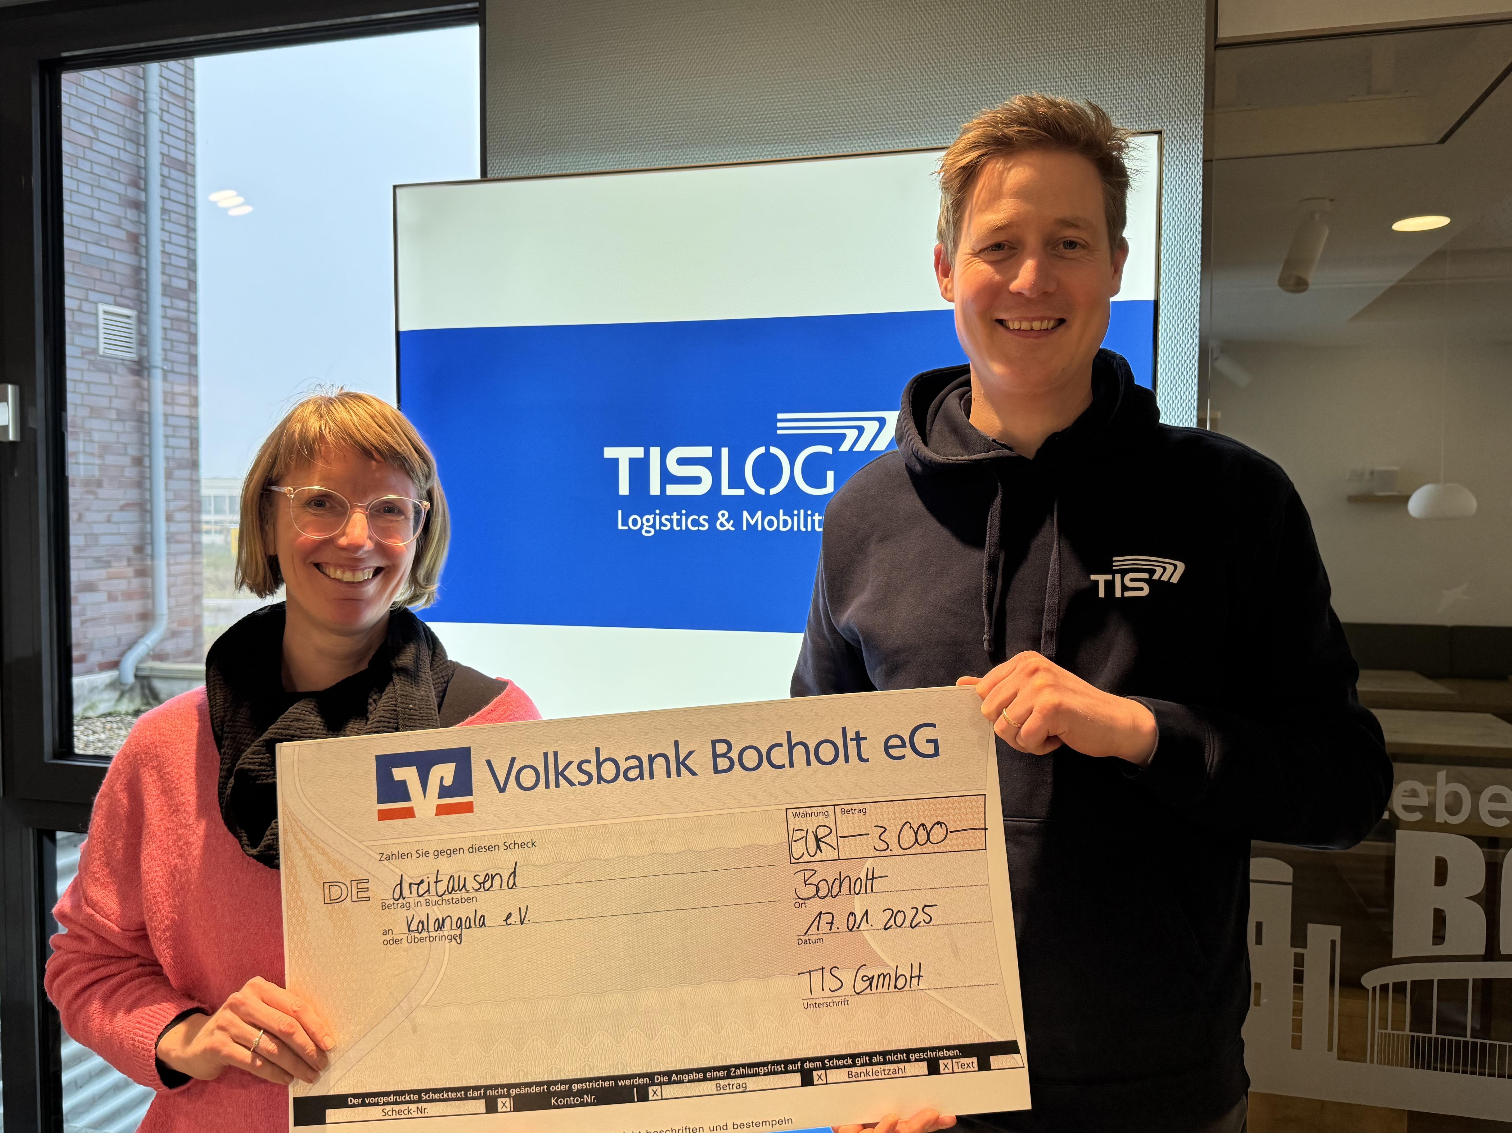

f.l.t.r. Simone Zingel, chairwoman of Kalangala e.V., and Fabian Bielefeld, managing director of TIS GmbH  
Photo: TIS GmbH