KRONE and TIS: New partnership for an easier exchange of telematics data

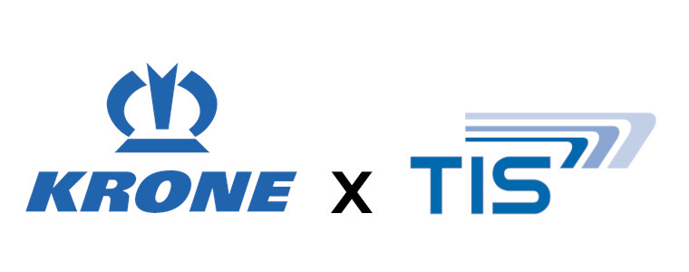

KRONE Commercial Vehicle Group and TIS GmbH have entered into an innovative partnership that makes the exchange of telematics data easier for their customers. The aim of this collaboration is to further advance digitalization in the logistics industry and enable fleet operators to use their data even more efficiently.

The cooperation makes it possible to seamlessly link the telematics data from KRONE vehicles and trailers with the TISLOG telematics software from TIS. Customers benefit from a uniform data overview that brings together all relevant information such as position, vehicle condition, temperature measurements and freight parameters in a single system. This centralized approach not only provides greater transparency, but also reduces the effort required to manage multiple systems.

“With TIS as a strong partner we are able to support our customers with the digitization of their logistics processes”, says Maximilian Birle, Head of KRONE Telematics. “Through the partnership we established a basis for an uncomplicated integration of vehicle and trailer data and a help for our customers to control their fleets more efficiently.”

The solution is particularly user-friendly because the customer can set up the forwarding of data in the respective system independently. Fabian Bielefeld, Managing Director of TIS GmbH, sees great potential in the collaboration: “The partnership with KRONE is an important step in giving our customers a holistic view of their fleets. With this integration, you save time, simplify your processes and can use resources more specifically.”

Linking the telematics data from KRONE and TIS offers clear advantages. Companies gain a real-time overview of their fleets, they are able to plan and monitor their transports better and benefit from a higher level of automation. These efficiency gains are essential to meeting the demands of modern supply chains.

With this partnership, KRONE and TIS are proving once again that the future of logistics lies in digital networking. Through a shared focus on innovation and customer focus, the companies are setting new standards for transparency and efficiency in the industry.

