TIS GmbH honors employees to their anniversaries
At the end of the year, TIS GmbH once again honored its anniversaries. In 2024 there were a total of five employees who were able to celebrate their company anniversary.

Four employees celebrated their 25th anniversary. These include Mike Ahlmann (Sales), Erwin Prinzen (Support), Robert Hams (Development) and Ulrich Möllmann (Support).
Furthermore, Michael Venhorst (Production) celebrated his 10th anniversary.

Markus Vinke, Managing Director of TIS GmbH, is pleased about the long working periods of the employees: “It’s great to see that many of our employees work with us for a long time.” Fabian Bielefeld, also managing director of TIS GmbH, adds: “I am proud of our team and am pleased that we have little fluctuation.”

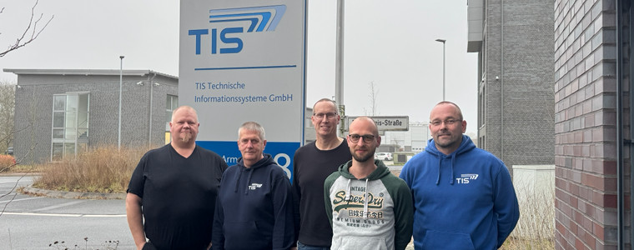
f.l.t.r.: Mike Ahlmann, Erwin Prinzen, Robert Hams, Michael Venhorst, Ulrich Möllmann
Photo: TIS GmbH

