**TIS GmbH donates 20.000€ to Kalangala e.V.**

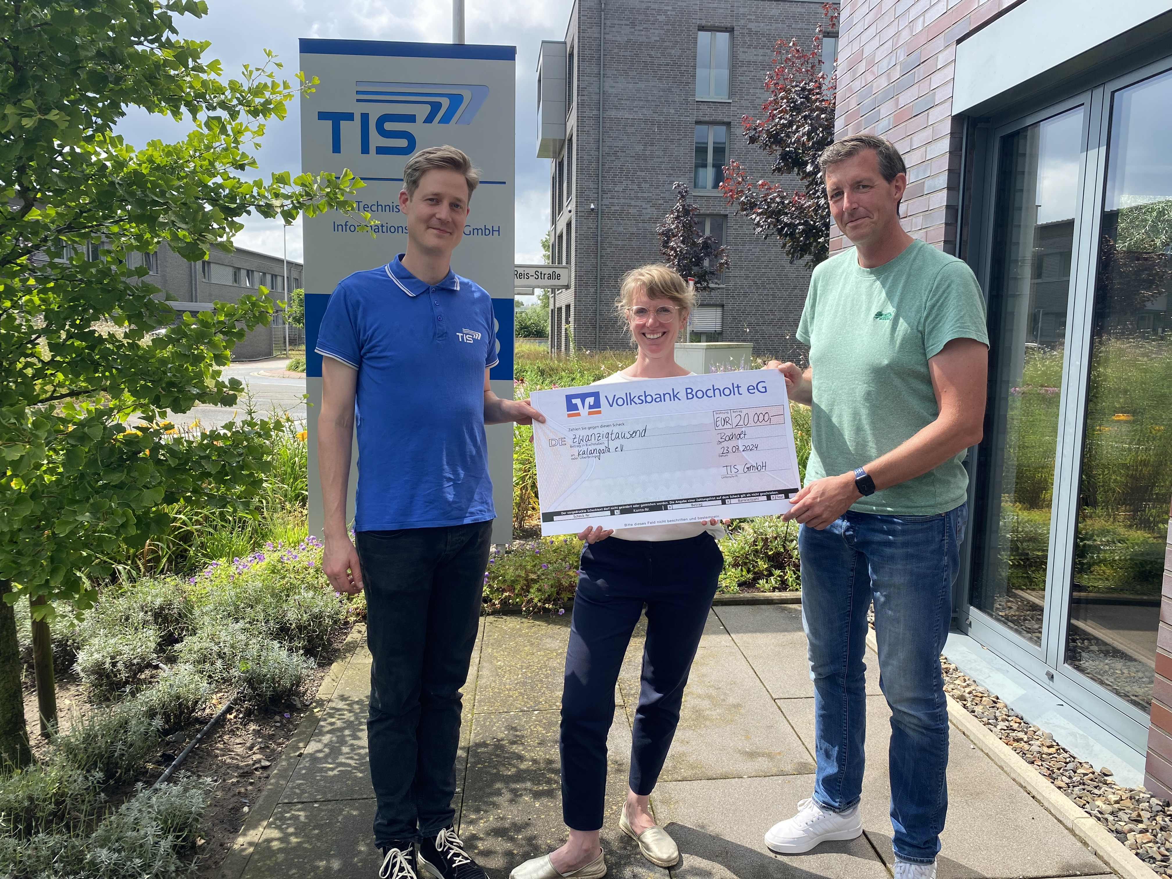

**Kalangala e.V. celebrates its 20th anniversary. Because of this, TIS GmbH decided to donate 20.000€ to the organization which advocates orphans in Uganda.**

TIS GmbH supports Kalangala e.V. for many years now. It is important to the company to support social projects. The organization focuses on the school education of oprhans in Uganda. The children get a good education and therefore also a good life perspective.

The family company donates a certain amount of money to Kalangala e.V yearly. Half of the money is collected through a tombala at the Christmas party and the other half is donated by the owner of TIS GmbH.

But as the organization now celebrated its 20th anniversary, TIS GmbH decided to donate again: 20.000€ to the 20th anniversary. Kalangala e.V. already knows what to do with the money. They want to build a new accommodation unit so that they are able to accommodate even more orphans.

Markus Vinke and Fabian Bielefeld, managing directors of TIS GmbH are happy that they can help Kalangala e.V. with this project. “We support the organization for many years now and we are impressed about the achieved goals”, says Fabian Bielefeld. Markus Vinke adds: “Kalangala e.V. informs us about its project regularly. We can have a look at photos and they give us presentations about the progresses. Because of this, we get a closer look at the projects that can be done with our support.”