Ökoprofit Certification
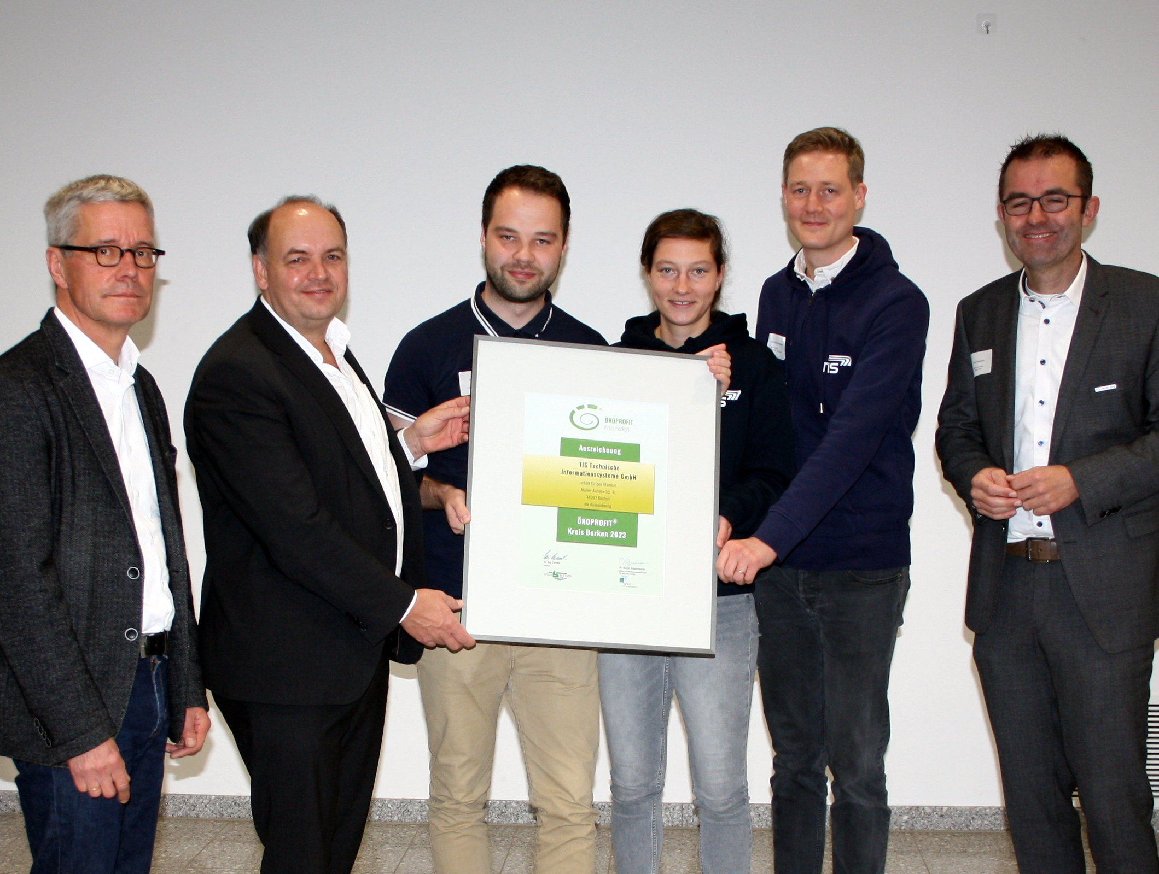
On October 27, 2023 TIS GmbH got the Ökoprofit Certification. Ökoprofit has the goal that companies act sustainable but that they are still competitive.

The Ökoprofit project started in 2022 and lasts for a year. In total, eight companies which are placed in Kreis Borken participated. The companies sat together regularly and learned how to stand up for the environment and how to act sustainable as a company.

Ökoprofit at TIS GmbH
At TIS GmbH four employees took care of the project. First of all, they documented the current status and then looked for room of improvements. Some of the improvements are already implemented, others are planned for 2024. Because of the good achievements and the engagement of the team, TIS GmbH got the Ökoprofit certification on October 27, 2023.

Implemented actions
- Conversion to e-mobility
- Using electricity from hydrodynamic power and wind energy
- Big garden
- Promotions for cycling
- Conversion to recycling papers
- Conversion to fairtrade coffee
- Conversion to CO2 neutral transportation
- Implementation of detachable plugs

Savings according to environmental program
With the already implemented actions TIS GmbH saves annually 3.600 €, 29t CO2 and 18.500 kWh energy.

