TIS GmbH honors employees to their anniversaries
At the end of the year TIS GmbH celebrated the employees anniversaries of 2023. A total of eight employees were honored.

Andre Tebrügge and Arnd Burchardt celebrated their 25th anniversary and Guido Elsingjorst his 20th anniversary. Bedies that, the employees Marco Schreiber, Carsten Dünne, Anna Demming, Mathias Emmerich and Dennis Lorei celebrated all their 10th anniversary.

Markus Vinke, Managing Director of TIS GmbH, is happy about the long seniority of the employees: “Staff retention is very important at TIS. It is nice to see every year all the employees that work for TIS for several years.” Fabian Bielefeld, also managing director of TIS GmbH adds: “ I am very proud of our team and I am happy that the employees feel good at TIS.”

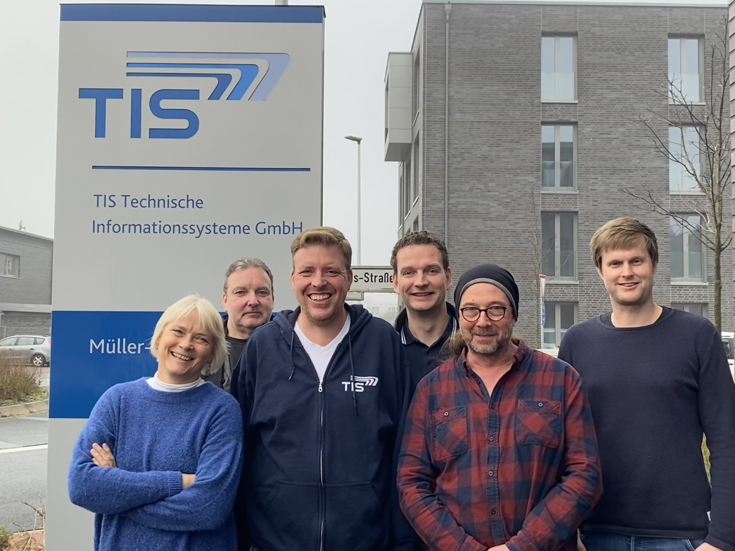
From left to right: Anna Demming, Andre Tebrügge, Guido Elsinghorst, Carsten Dünne, Arnd Burchardt, Mathias Emmerich Missing: Marco Schreiber and Dennis Lorei

