TIS GmbH honors employees to their anniversaries
At the end of the year TIS GmbH celebrated the employees anniversaries of 2022. A total of six employees were honored. Some of them started to work for the company shortly after its foundation.

TIS GmbH stands out for its employee engagement. Most of the workers stay in the company for many years. So six employees celebrated their anniversary in 2022.

Ralf Mülder was honored for his 35 year anniversary and Berthold Klump and Reinhard Gaelings celebrated their 30 years anniversaries. Furthermore, there are three employees who work for TIS for 20 years. These are Norbert Roßkamp, Rainer Schlüß and Frank Schmeinck. In addition, Bernd Boll-Dullhot celebrated his 10 years anniversary.

Markus Vinke, Managing Director of TIS GmbH, is proud that he is able to honor employees for their company anniversaries every year. “The many employees working for TIS for numerous years show that TIS is an attractive employer and that the workers are feeling good. That is very important for us.”

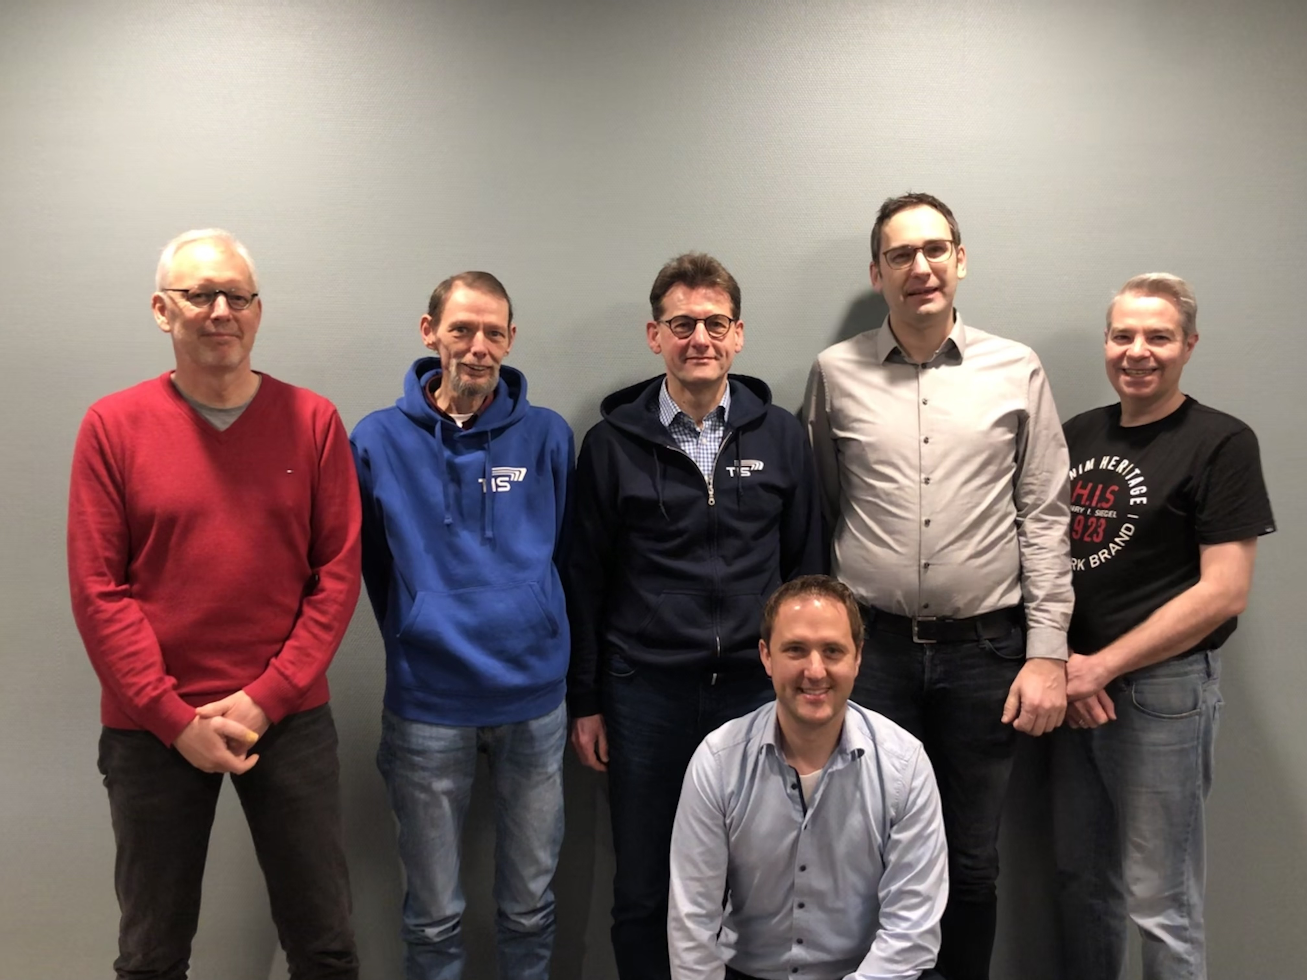
From left to right: Ralf Mülder, Rainer Schlüß, Berthold Klump, Bernd Boll-Dullhot, Norbert Roßkamp, Frank Schmeinck; Reinhard Gaelings is missing

