TIS GmbH wins at German Telematics Award
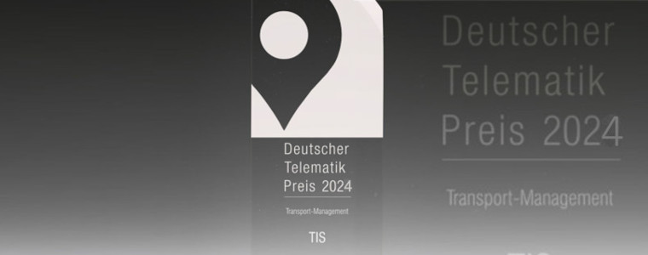
TIS GmbH wins at German Telematics Award 2024 the first place in the category transport management. The award ceremony took place during the DEKRA Future Congress on October 31.

The German Telematics Award is looking on a yearly basis for the best telematics systems. There are different categories the companies can choose from. These are: asset management, public transportation, driver management, vehicle technology, field service (car, transporter), locating/tracking, realtime transport visibility platform (RTVP), special vehicle, trailer and swap body technology and transport management.
For finding the winners of each category the companies have to do different tests. First of all, they have to answer a criteria catalogue which asks for the general information of the solution and its special functions. This catalogue is reviewed with a certain pattern. The three solutions that are reviewed the best for every category are nominated for the German Telematics Award. This means they reach the second test phase. In this the jury will have a closer look on the usability, the embodiment and the different functions of the solution. In the following phase there is another catalogue which has to be filled in. This one asks for the distribution, innovative capacity and the perspective of development. The results of both test phases are then combined and a winner for each category is selected.
This year the jury of the German Telematics Award consists of Prof. Dr. Heinz Leo Dudek (DHBW Ravensburg), Stephan Feitzelmayer (SF Telematik), Martin Trümper (DEKRA), Andreas Schmidt (BGL), Carsten Nallinger (ETM) and Johannes Nikolaus Nießen (P3 Group).

TIS GmbH wins
TIS GmbH was nominated in two different categories: special vehicles and transport management. In the end, the service provider made the first place in transport management.
The award ceremony took place during the DEKRA Future Congress on October 31, 2023. Mike Ahlmann, Division Manager Groupage Cargo Transport at TIS GmbH, accepted the award with thanks.
Managing directors Markus Vinke and Fabian Bielefeld are proud that they have made the first place: “The fact that we won the German Telematics Award in the category Transport Management shows us, that we have gone the right path with our TISLOG software. We want to thank our employees for their work because only as a team we are able to succeed.”

