“THE TISLOG APP MEETS OUR DEMANDS ENTIRELY”
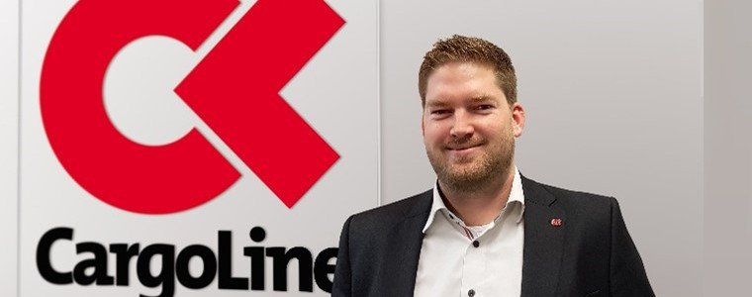

Sebastian Grollius, Head of IT and Project Management at CargoLine, talks about the advantages of an easy configurable driver app and the cooperation with TIS.

Mister Grollius, which meaning does an uniform driver app has for CargoLine?
Sebastian Grollius: In general, each CargoLine partner is able to choose the driver app itself. But the app has to fulfill our requirements such as providing the status of the sending or sending the estimated arrival time. Furthermore, there are changes in the delivery process regularly which have to be implemented by our partners quickly. Different IT solutions mean a longer term of process implementation. For this, we were looking for a driver app which fits to all our partners and which can be adjusted quickly and with little effort. This saves money and time.

What do you mean with little effort?
Sebastian Grollius: With little effort I mean that the changes can be made by every partner quickly and without external help and costs. This functions with modern configurations which digitize the supply chain between pickup, storage, stock removal and delivery without programming knowledge. The TISLOG app by TIS offers such a configurator. This configurator offers the definition of certain input fields on the mobile device which have to be filled in by the driver or the warehouse worker. The so called Live Configurator offers even a spontaneous creation of new data fields. The interface to TISLOG is expanded automatically.

Is there an official recommendation for using the TISLOG App within CargoLine?
Sebastian Grollius: In general, we are neutral. But I can say with clear conscience that the TISLOG app works well and that it entirely meets our demands. The solution offers a high data transparency and a flexible workflow design. The app is easy to use and leads the driver in his favored language through the whole process. Furthermore, TIS is an efficient, independent and medium-sized company which can be used by our partners trustfully.

How widely spread is the TISLOG software within CargoLine?
Sebastian Grollius: 22 German CargoLine partners which represent approximately half of the sendings of the group work with the solution of TIS. These partners give me a positive feedback. But also the cooperations center of CargoLine works fair with TIS. As an example the company presents itself at our conference for IT managers yearly.

How does the process of new requirements work?
Sebastian Grollius: In the standard process CargoLine informs its partners about the new requirements. In the next step our partners get into contact with their IT suppliers. As the case arises I talk beforehand with TIS to announce the coming changes. These changes can then be included in the standard by TIS so that there are possibly no further costs for our partners. In addition, this course of action simplifies the communication and quickens the process.

How important is the aspect that TIS offers also suitable hardware?
Sebastian Grollius: For us, the software is the main aspect as it provides us the information to the sendings. But we are happy that suppliers such as TIS are able to provide quick replacements in the case that mobile devices are not working anymore. Besides repairs, TIS also offers a comprehensive service including the configuration and the individual adjustment with vehicle cradles and scan handles. Because of this, TIS stands out against other suppliers.

Thanks a lot for the conversation, Mister Grollius!

